Contents

1. Definitions of Firmware 2

2. Firmware Updates 2

3. Firmware Versions 3

4. Firmware Update Process 3

# Definitions of Firmware

In electronic systems and computing, firmware is a specific class of computer software that provides low level control for the device's specific hardware. Firmware can either provide a standardized operating environment for the device's more complex software (allowing more hardware independence). For less complex devices, firmware may act as the device's complete operating system, performing all control, monitoring and data manipulation functions.

A television remote control is an example of an engineered product that contains firmware. The firmware monitors the buttons, controls the LEDs, and processes the button presses to send the data in a format the receiving device, in this case, a television set, can understand and process. In fact, the television's mother board has a complex firmware too.

# Firmware Updates

Firmware rarely has a well-evolved automatic mechanism of updating itself to fix any functionality issues detected after shipping the unit. Therefore, periodic firmware updates are conducted, so functionality issues and bugs can be fixed.

A software bug is an error, flaw, failure or fault in a computer program or system that causes it to produce an incorrect or unexpected result, or to behave in unintended ways. The process of fixing bugs is termed "debugging" and often uses formal techniques or tools to pinpoint bugs, and since the 1950s, some computer systems have been designed to also deter, detect or auto-correct various computer bugs during operations.

Galooli hardware equally works on software which is prone to bugs.

# Firmware Versions

History of Galooli devices including past and present firmware versions

|  |  |  |  |  |  |  |  |  |  |
| --- | --- | --- | --- | --- | --- | --- | --- | --- | --- |
|  |  | **Software Versions** | | | | | | | |
| **Number** | **Unit type** | **First release version** | **Updated** | **Updated** | **Updated** | **Updated** | **Updated** | **Updated** | **Latest** |
| 1 | Corona K2 | 3.04 | 3.06 | 3.07 | 3.08 | 3.29 | 3.30 | 3.31 | 3.32 |
| 2 | Corona Triton 5 | 1.28 | 1.29 | 1.3 | 1.31 | 1.32 | 1.33 | 1.34 | 1.36 |
| 3 | EX 6i |  |  |  |  |  |  | 2.09 | 2.12 |
| 4 | EX 6s |  |  |  |  |  |  | 2.09 | 2.12 |
| 5 | Ex 20 SSR |  |  |  |  |  |  | 2.03 | 2.04 |
| 6 | Ex 20 ETH |  |  |  |  |  | 1.05 | 1.05 | 1.06 |
| 7 | Vepamon Sensor |  |  |  |  |  |  |  | 1.0.1.3 |

# Firmware Update Process

Firmware updates are conducted via the Power Center using 2 methods of communication:

* Serial connection
* OTA application

The upgrade is done using the following:

* A PC installed with power center application.
* User must have power center login account.
* USB RS 485 serial converter.

Refer to the screen shot below for power tool architecture

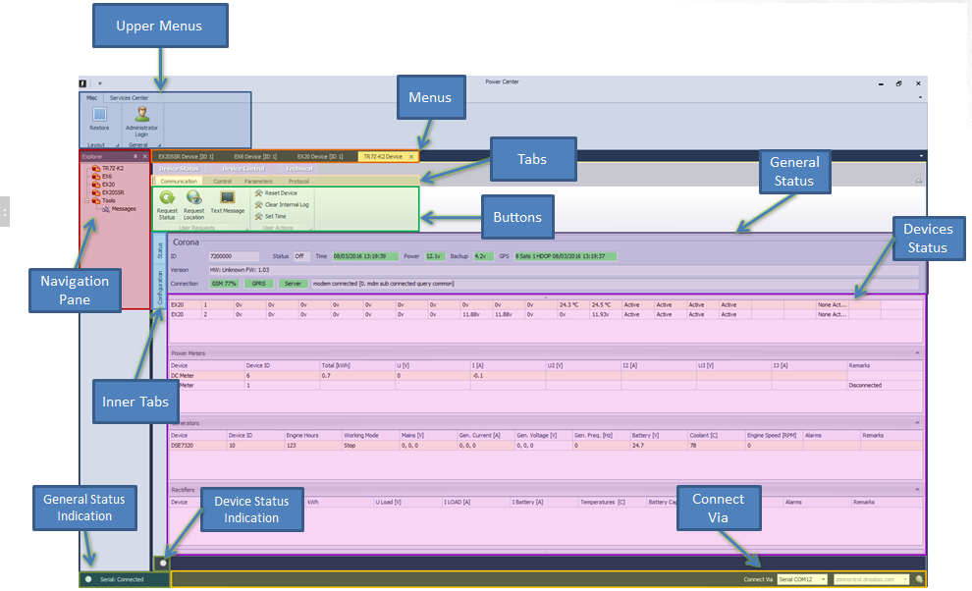

**Serial Connection**

Corona set up with devices connected

PC

Connection to a laptop

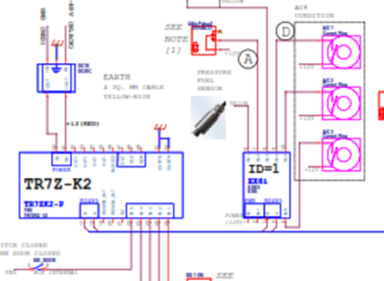

or PC

**OTA Update**

The OTA update is preformed remotely using an internet connection

The action is initiated by the user and continues in the server till the process is complete

Note:

1. This is only applicable to the Triton corona unit
2. The unit must have good internet connectivity.
3. The unit must be connected to the server.

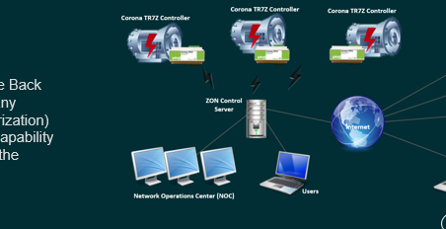

**Galooli Corona**

**Internet**

**Remote PC**

**Server**

**Internet**

1. Software generally refers to high level programs while firmware is used to microcode embedded in most hardware

2. Software can be very big while firmware are usually very small

3. Software can be replaced without much hassle while replacing firmware is often difficult

4. Software is often stored in user accessible memory while firmware is located in an inaccessible storage embedded in the hardware

# Software is changed constantly while firmware is very rarely changed

Firmware is basically a type of software,